RETURN TO SOCCER PLAN
EFFECTIVE JUNE 25, 2020

DISCLAIMER
The information in this document is not intended or implied to be a substitute for professional medical advice, diagnosis, or treatment. All content, including text, graphics, images, and information, are provided for general informational purposes only. The knowledge and circumstances around COVID-19 are changing constantly and, as such, Weyburn Soccer makes no representation and assumes no responsibility for the accuracy or completeness of this information. Further, you should seek advice from medical professionals and/or public health officials if you have specific questions about your return to training and competition.

Weyburn Soccer does not represent, warrant, or endorse the completeness or timeliness of any of the information, content, views, opinions, or recommendations contained in the information provided. This information is accepted on the condition that errors or omissions shall not be made the basis for any claim, demand, or cause for action. It is the responsibility of the reader to perform proper due diligence before acting upon any of the information provided. Prior to using this information, obtain proper legal advice from a person authorized to give it. In no event, will Saskatchewan Soccer be liable for any direct, indirect, incidental, punitive, or consequential damages of any kind whatsoever with respect to these materials.
It is important to know that summer soccer has not really existed in an organized form in Weyburn. The traditional house league and traveling competitive teams have all ended playing at the end of June. Our return to play plan is developed on the premise that it will proceed if and when coaches commit to helping out. Our return to play will only be organised for our player development programs (rep teams). When we first announced our cancellation, we mentioned offering free soccer in the park. With the guidelines and phased in approach that SSA and CSA approved we recognize this may not be possible. Weyburn Soccer will remain committed to soccer in the park and with City of Weyburn permission we will place sets of soccer nets around the city green spaces and encourage you to go play while following the Government of Saskatchewan and City of Weyburn guidelines for safety.

CANADA SOCCER RETURN TO SOCCER GUIDELINES

Guided by leadership from Canada Soccer's Sports Medicine Committee and in consultation with federal, provincial, territorial and local public health authorities, Canada Soccer created the below Return to Soccer Guidelines to provide member organizations with a five-step process, including a checklist of weighted questions known as the Return to Soccer Assessment Tool, all for the purpose of determining preparedness to mitigate COVID-19 risks and implications upon the resumption of soccer and related activities.

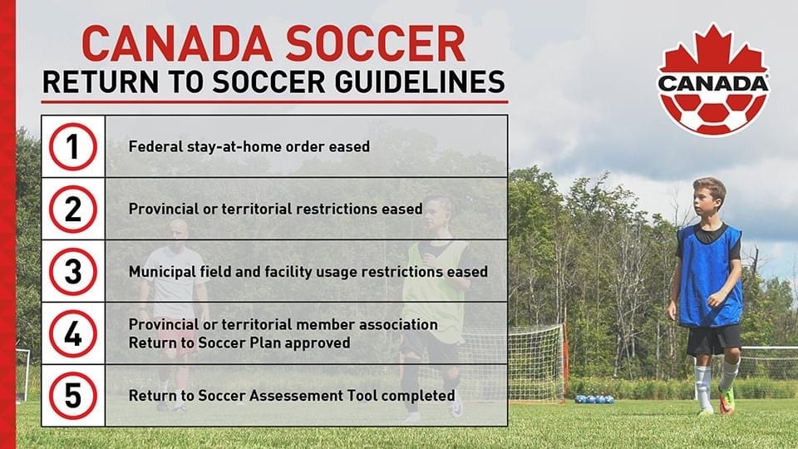

SSA Return to Soccer Plan
With support from Canada Soccer, Sask Sport, and other provincial soccer associations, SSA has developed the Return to Soccer Plan (RTSP) to serve as a guide to assist SSA Member Organizations in the safe reintroduction of soccer. The plan uses a multi-phase approach for a thoughtful and cautious return to the pitch. This document will be dynamic and will be updated as new information becomes available. This document is not exhaustive, and Member Organization’s must also ensure they do their due diligence to ensure they are prepared to return to soccer. Ultimately, when all guidelines are followed and restrictions are eased, it will be the Member Organization’s decision if they are ready to offer opportunities to return to play and the participant’s decision to determine if they are ready to play, coach, referee, or volunteer, considering the associated risks.
It is also essential that all Government of Saskatchewan guidelines are followed in conjunction with this plan. Soccer is believed to be in Phase 4 of the re-open Saskatchewan Plan. We have not received provincial government guidelines for sport at this time but will adapt accordingly once that information is received.

Saskatchewan Soccer's Return to Soccer Plan

Phase 1 – Return to Train (no contact) - Social Distancing measures are in place, Technical Based Activities
*Opposition may be created utilizing individuals from within same household or family bubble.
Phase 2 – Return to Train (Minimal Contact) - Social Distancing measures are being relaxed - Small Group Activities (1v1 to 3v3)
Phase 3 – Return to Play (Increased Contact) - Social Distancing measures are relaxed, further intro of Small Game Formats (1v1to 7v7)
Phase 4 – Return to Play (Full Contact) - Social Distancing measures are removed, All Game Formats (1v1 – 11v11)

Social Distancing (Phase 1): Contact is considered anything less than the 2 metres between participants; no contact is allowed in this phase.
Technical Based Activity: Activities that do not require opposition within 2 metre proximity, therefore, allowing players and coaches to maintain social distancing. Examples could be individual ball mastery, passing and receiving on the ground between partners, relays and other competitions/challenges that maintain social distancing.

Small Group Activities: Include activities with opposition. Numbers for the activities should be between 1v1 to 3v3. Try to keep players in groups together so that they work with similar players rather than constantly mixing players together (can increase number of players interacting with an asymptomatic COVID-19 carrier)
Small Game Formats: Game formats of 1v1 to 7v7. Recommendation within RTSP Phase 3 would be to keep this in-house versus playing against different clubs. Recommendation against festival type formats where one team plays against many teams on a given day (reduce number of individuals that may encounter potentially an asymptomatic COVID-19 carrier).
All Game Formats: Introduction of all game formats.
The Saskatchewan Government is to provide guidelines around what will be acceptable for the resumption of sport regarding areas such as social distancing and max capacity for facilities. While there is a desire to return to normalcy during COVID-19, everyone must remain conscientious about the safety and welfare of all participants as the primary consideration. As such, there is an increased importance around the due diligence required to keep all participants safe and prevent community transmission by organizations that make the choice to deliver soccer programming.

Government of Saskatchewan Outdoor Sport Guidelines

Outdoor sports and recreational activities for children and adults may resume, including activities taking place on soccer fields, volleyball and basketball courts, baseball diamonds, lawn bowling greens and football fields. Operators must implement measures to prevent the transmission of COVID-19. COVID-19 droplet transmission is much more likely when individuals are in close contact. The likelihood of transmission between individuals participating in sport, physical activity and recreation in an indoor setting is significantly higher. Transmission is less likely in an outdoor setting, where air flow is greater and there is more space for individuals to keep physically distanced. COVID-19 can also be transmitted if someone touches a contaminated surface and then touches their face without washing their hands. Many activities involve shared equipment among participants, coaches/staff, instructors, officials or volunteers (e.g. shared baseballs, basketballs, volleyballs). The virus does not enter the body through skin; it enters through the eyes, nose or mouth when an individual touches their face. This is why regular hand hygiene and cleaning of high-touch surfaces are so important.
Each sports organization and/or facility must establish a plan for how to minimize physical contact and the risk of COVID-19 transmission between participants. The guidance should align with provincial and national sporting bodies for each activity and be at least as restrictive as provincial guidelines. This guidance is not intended to apply to professional sports teams with COVID-19 response plans.

WSA Covid-19 Protocols
Communication/Response Action Plan:
- Tyler Hillstead has been designated as WSA’s Specific Person On all things related to COVID. (SPOC)
Email – wsagrassroots@sasktel.net
Phone – (mobile) 306 861 7722 - (home) 306 848 2037
Key Contacts:
City of Weyburn – Andrew Crowe 848 3200
Government of Saskatchewan Public Health - 811
- Coaches and parents of participants must sign and date the SSA “Release of Liability, Waiver of Claims and Indemnity”. Which will be part of the registration process.
(a) Declaration of Compliance - (Covid -19)
(b) Youth Release Waiver
(c) Medical Information Form
- If a player that screens positive and/or presents with Covid-19 like symptoms, their parent will be notified and the player will be removed from the field and will be placed in a designated pick up spot (12th Street entrance), which is not being used for entry or exiting by players. They will be directed to contact 811 or their family physician, who can refer for a Covid-19 swab. Physicians may refer for an assessment at the Testing/Assessment site if they deem necessary. In the event of a positive swab, Tyler (SPOC) would provide Public Health with the groupings of players on the field at the same time as that player. We would then cancel the remainder of the sessions for that age group of players until all participants have been cleared through testing.
- If a player is swabbed and results are negative, they will be permitted to attend the next scheduled session, provided they are cleared by Public Health to discontinue self-isolation and a doctor's note needs to be provided to SPOC.
Players:
Each player will need to bring the following to the pitch:
- Personal water bottle (with athlete’s name on it)
- Personal soccer ball (with athlete’s name on it) (if a player does not have one a disinfected ball will be provided for them that must be signed out and returned at the end of training dates, no return fee maybe applied if not returned)
- Hygiene bag (hand sanitizer, disinfectant wipes, tissue paper, cloth or procedure mask, any First Aid material they may need)
- Players are asked to bring a light and dark colored shirt
If a player does not come to the field with items 1 and/or 3, they will not be permitted to participate in the training session.
Players will not be allowed to participate if:
- They have travelled outside the province within 14 days of training
- Been to a gathering of people greater than 30 people outdoors or 15 people indoors
- Show signs and symptoms of Covid -19

Accessing the Fields
Players must:
- enter the fields VIA Douglas Road entrance via the North entrance.
- have their attendance taken by the COVID check in person.
- show proof of personal water bottle and hygiene bag to COVID check in person.
- hand sanitize before stepping onto the field.
- players must arrive 5-10 minutes prior to training time and respect the social distancing guidelines and place belongings 2m from other players.
Water Breaks:
During water breaks players must remain with their quadrant of players, sanitize before they drink from their personal water bottle and sanitize their hands using supplies from their hygiene bag before restarting training activities.
Exiting the Fields:
Players will exit the same way they entered the field as WSA will schedule 30 mins between age groups arriving/exiting the field.

Parents or Spectators:
U7 – U9 Age Groups - 1 Player + 1 Parent/Guardian/Sibling
Children at this age often need interaction with someone to remain engaged and complete technical based activities. We cannot expect young children to be responsible for maintaining social distancing. Players may not have yet developed focus to find isolated practices with a ball enjoyable. Therefore, utilizing a parent/guardian/sibling to partake in the practice will provide a more fulfilling experience as it will increase the number of different activities the athlete can experience as social distancing does not need to be maintained by people from the same household. This will help create opportunities to plan activities that include a partner or opposition. Be overly conservative when spacing out areas to maintain social distancing.
Maximum allowance per group will be 12 players plus parents/guardians/siblings up to 30 total.

U11 + Age Groups:
Parents will not be permitted to enter the field with players unless they are involved with session. Parents may watch from tree line in front of their park car and MUST social distance 2m from other families.
**Parents may not be allowed to watch of they do not respect this rule.
Coaches:
- All Coaches and Volunteer supporters must complete pre-activity safety orientation on all safety protocols as per provincial guidelines aligned to Phase 4 of the Re-open Saskatchewan Plan – hand washing, cough suppression, body fluid emissions strictly controlled (for example: spitting, mucus, vomit or other bodily fluids may not be expelled in public areas, immediate clean up required).
- to ensure Safe Sport Roster & Rule of Two are maintained and one coach is of the same gender as the athletes.
- Familiarize themselves with the Communications/Response Action Plan and Symptom Reporting Process This would include being prepared to shut down operations quickly and efficiently.
- Assign personal as the Covid check in person to take attendance at each training session.
- Email/ Screen shot Tyler the check in form after each session making sure the date is correct.
- Coaches are responsible to ensure a safe environment for the athletes and on field support staff and volunteers.
- Coaches or trained designates must wipe equipment down using disinfected swabs or towels, before and immediately after each session (do not go home and then clean – contaminated items may travel into coach's home environment.
- Structure activities to maximize physical distancing – RTSP Phase 1
- Age Appropriate considerations may need to be taken when designing activities, for example, Active Start and Fundamentals players may need a sibling or parent to participate with them. This will allow for coaches to have support managing the group of players and social distancing will not be required between siblings or parent/child (since they are from the same family). Support volunteers must receive safety orientation and be registered.
- Design activities so athletes may stay within their existing small groups within RTSP Phase 2 to reduce amount of contact with different people.
- Ball should stay below the waist to prevent contact with head, hands, chest, mouth in RTSP Phases 1-3.
- Regular sanitization breaks combined with water breaks.

